**Assignment 1**

import pandas as pd

df=pd.read_csv(r"E:\Machine Leraning\Day 4\Player.csv")

df

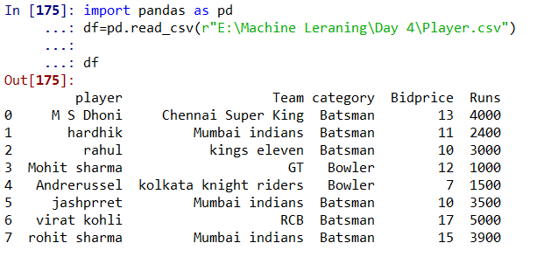

**1. display all bowlers.**

df[df['category']=='Bowler']

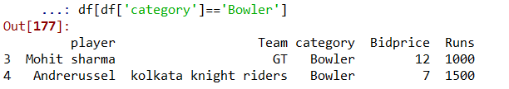

**2. Display all players of mumbai Indians**.

df[df['Team']=='Mumbai indians']

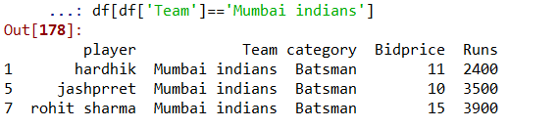

**3. Display all mumbai indian players with run greater than 3000.**

df[(df['Team']=='Mumbai indians')&(df['Runs']>3000)]

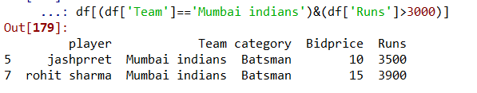

**4. display the details of players who play for RCB or chennai super king**

df[df.Team.isin(['RCB','Chennai Super King'])]

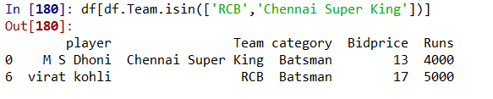

**5. print the average bid price and run**

df[['Bidprice','Runs']].mean()

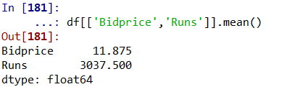

**6. sort the player by the bidding price.**

df.sort_values(by='Bidprice')

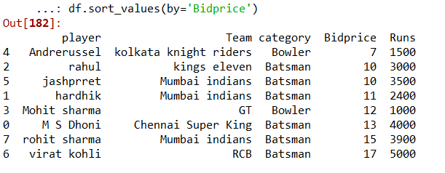

**7.find most expenssive player**

df[df['Bidprice']==df['Bidprice'].max()]

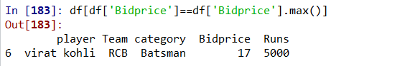

**8.find the player with lowest run**

df[df['Runs']==df['Runs'].min()]

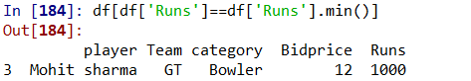

**9. print the total player/no. of rows in a dataset**

len(df)

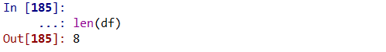

**10. print total players per each team**

df.groupby('Team')['Team'].count()

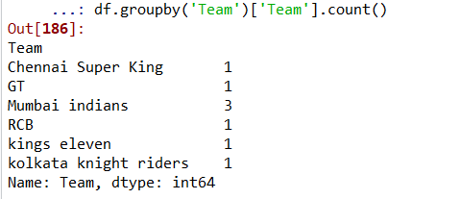

**11. find player who had highest bid price from each team**

df.groupby('Team')[['Bidprice','player']].max()

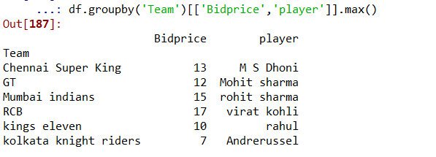

**12. Find the average run for each team**

df.groupby('Team')[['Runs']].mean()

